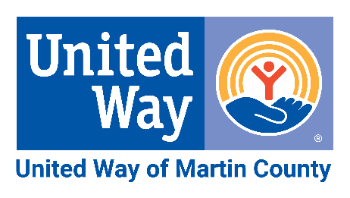
ROLLOVER CAMPAIGN

As we witnessed in recent years, with every new challenge, we see our community rise to the occasion. We are so grateful that you have been there along the way – a true champion that Lives United. Looking forward, we know that you are an integral part of our community’s strength. As always, we appreciate your continued support of United Way of Martin County.
We understand that some businesses are still rebounding from the pandemic and changes in the economy. Your annual United Way campaign might need to look a little different in order to best meet your needs while still offering support to those most vulnerable in our community. As a solution, many of our Corporate Partners have adopted Rollover Campaigns as an effective way to maintain employee engagement, boost morale, and enhance corporate social responsibility.
WHAT IS A ROLLOVER CAMPAIGN?
A Rollover Campaign takes your employee giving (payroll deductions) from last year’s annual campaign and automatically rolls it over to the 2022/2023 campaign including gift amount, type of pledge and any designations, unless any changes are specified by the employee. Any gifts that were made via cash, check or credit card are not eligible for rollover and would need to be made by the employee as a new gift. Any employee always has the option to make changes to their gift including an increase, decrease or other adjustment based on their personal situation.
WHAT STEPS ARE INVOLVED?
- Complete and submit the Rollover Campaign confirmation form. Please complete the information on the back of this sheet with all the details necessary to get started.
- Provide a list of current employees participating in payroll deduction. By providing your list of employees who are currently participating in payroll deduction, we can make sure our records are up to date.
- Define your timeline for when you want to run your campaign. Right before your campaign, you’ll need to communicate to your employees the details of how they can make adjustments to their existing payroll deductions. We recommend a 2-week window for employees to adjust their contribution including designations or adjustment in amount.
- Determine a point person – a Campaign Coordinator – for employees to contact regarding changes to their contribution or renewals with cash, checks or credit card donations.
- Reach out to new employees that have joined since the end of your last campaign. Provide new staff with United Way info and a pledge form or link to online pledge platform.
- For any new employees or changes for existing donors, submit pledge forms to your United Way contact at the end of your campaign.
WHAT TOOLS CAN UNITED WAY PROVIDE?
- Communication Plan: We will provide sample communication to help you inform your employees about the campaign as well as answer questions that might come up.
- Campaign Presentations: United Way staff members are available to you for inspiring presentations as to how employee contributions can change lives in our community.
ROLLOVER CAMPAIGN

ROLLOVER CAMPAIGN CONFIRMATION FORM

Our company/organization will implement a Rollover Campaign for the 2022/2023 Annual United Way Campaign. We understand that this means all employee payroll deductions submitted for the 2021/2022 campaign will be continued at the same amount for the 2022/2023 campaign, including designations, unless otherwise notified by the donor of any changes.
* 2021/2022 Campaign – July 1, 2021 – June 30, 2022 (payroll deduction calendar year 2022)
* 2022/2023 Campaign – July 1, 2022 – June 30, 2023 (payroll deduction calendar year 2023)

COMPANY/ORGANIZATION NAME: _________________________________________________

CAMPAIGN COORDINATOR NAME: _________________________________________________

TITLE: _____________________________________________________________________________

EMAIL: ______________________________________ PHONE: ____________________________

SIGNATURE: _________________________________ DATE: _____________________________

Return confirmation form to:

Elisabeth Glynn, CFRE
Director of Philanthropy
eglynn@unitedwaymartin.org

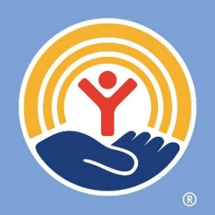
United Way of Martin County
10 SE Central Parkway, Suite 101
Stuart, FL 34994
772-283-4800

www.unitedwaymartin.org
@UnitedWayMartin

